**Industry Level Analysis**

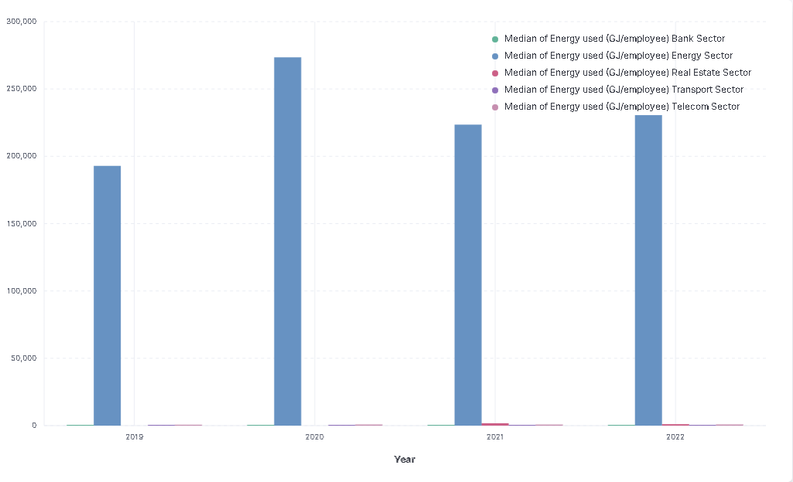

**The Energy sector (dark blue) has the highest median energy use per employee, consistent with energy-intensive operations.**

**The Transport sector (purple) and Real Estate sector (red) exhibit lower median energy use, with the Telecom sector (light pink) using the least energy per employee.**

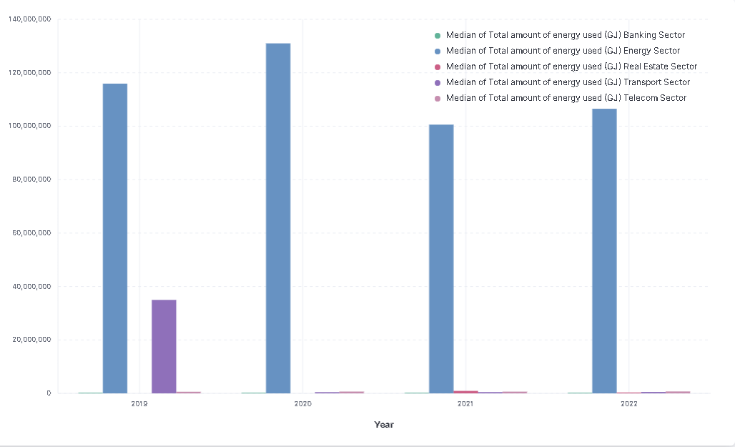

**The Energy sector (dark blue) dominates in total energy use, which aligns with it being an energy production-focused sector.**

**The Banking sector (green) shows a lesser total energy use, while the Telecom sector (light pink) remains the least among all, suggesting it is less energy-intensive overall or more energy-efficient.**

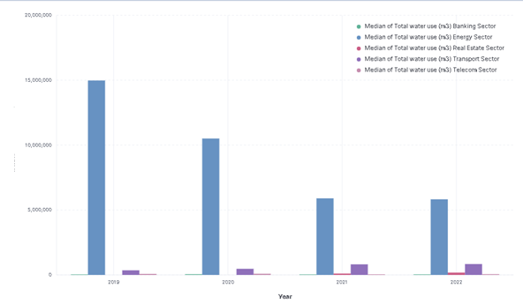

**The Energy sector (dark blue) stands out with the highest median total water use..**

**The Banking sector (green) and Transport sector (purple) use a considerably lesser amount of water, which is still significantly more than the Telecom sector (light pink) and Real Estate sector (red), with the latter two showing the lowest water use.**

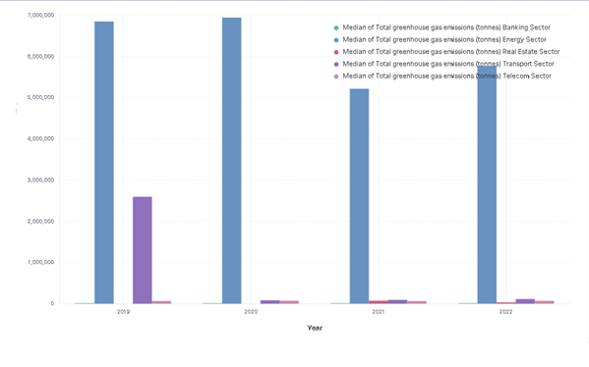

**Again, the Energy sector (dark blue) emits the most greenhouse gases by a substantial margin, correlating with its high energy use.**

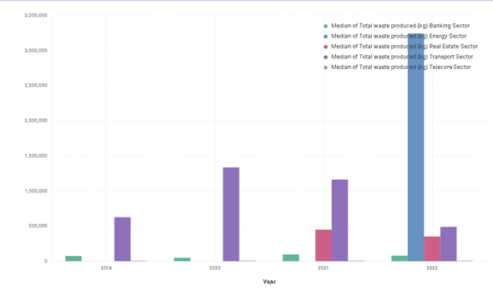

**The Transport Sector had a steady rise and decrease the Total waste produced over the years 2019-2022 but in 2022 the energy sector had a sudden rise in the total waste produced**

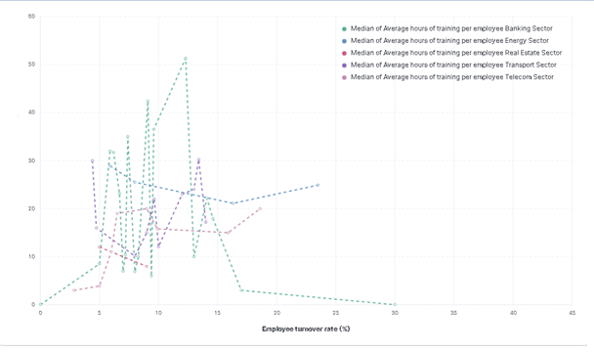

**The graph indicates that the Banking sector (green) provides a high number of average training hours per employee, with varying employee turnover rates.**

**The spread of data points indicates a diverse impact of training on turnover rates within these sectors.**

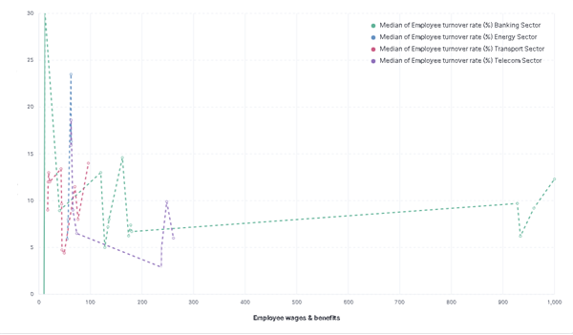

**The Telecom sector (purple) and Banking sector (green) show a broad spread of turnover rates across different levels of wages and benefits, suggesting multiple factors could be affecting turnover rates beyond compensation**

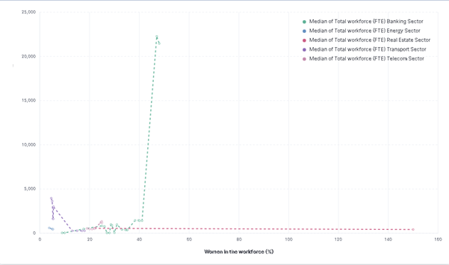

**The Banking sector (green) has the highest representation of women in the workforce and also one of the larger workforces (FTE).**

**Other sectors, such as Telecom (light pink) and Energy (dark blue), display a lower percentage of women in their workforce, highlighting potential gender disparity in these industries**